Smart Solar Panel Maintenance: A Data-Driven Approach Using IoT and Machine Learning

# Prof. Sulalah Mirkar

*Department of Information Technology NMIMS, MPSTME*

Mumbai, India [sulalah.rizwani@gmail.com](mailto:sulalah.rizwani@gmail.com) Arya Popat

*B.Tech Information Technology NMIMS, MPSTME*

Mumbai, India [aryapopat21@gmail.com](mailto:aryapopat21@gmail.com)

# Samahit Juvekar

*B.Tech Information Technology NMIMS, MPSTME*

Mumbai, India [juvekarsamahit@gmail.com](mailto:juvekarsamahit@gmail.com) Heet Jain

*B.Tech Information Technology NMIMS, MPSTME*

Mumbai, India [heetjain13@gmail.com](mailto:heetjain13@gmail.com)

***Abstract*—This paper presents a solution for optimizing solar panel maintenance through a simple Arduino-based cleaning system. The system utilizes sensors to monitor environmental factors and trigger automated cleaning as needed. Additionally, a machine learning (ML) model forecasts future conditions and predicts cleaning requirements based on historical data, ensuring proactive maintenance that minimizes downtime and maximizes energy production. The paper demonstrates how this Arduino-based smart cleaning system is more efficient than manual cleaning of solar panels. It details the system’s design, implementation, experimental results, and economic implications, highlighting benefits such as reduced labor costs, lower water consumption, and increased energy efficiency. Furthermore, the paper discusses potential future advancements, including en- hanced sensor integration and AI-powered tracking capabilities. *Index Terms*—Solar panels, Machine Learning, Arduino, Re- newable energy, IoT, Predictive maintenance, Water Conserva-**

**tion, Solar Energy Conservation, Sustainability Development**

1. Introduction

Solar energy is one of the emerging sources of renewable energy but gets significantly reduced by giant amounts of dust collecting on solar panels. Thus, cleaning is indispensable, but the conventional manual methods are time-consuming, expensive, and waste of water. The paper under discussion aims at designing an Arduino-based real-time cleaning sys- tem that integrates a machine learning model for predictive maintenance. The Arduino system makes use of sensors for dust levels, light intensity, and humidity. It will automatically activate the microfiber brush mechanism for dry cleaning when the condition exceeds that of a user-defined threshold or a learned pattern, hence removing the labor force and water usage. The ML model predicts conditions in the environ- ment affecting efficiency based on time series data such as temperatures and humidity. A classification algorithm decides upon when cleaning is necessary, hence scheduling proactive maintenance, which minimizes downtime while maximizing energy production. The system’s design and implementation of this paper include cleaning hardware, ML algorithms,

and user-friendly dashboard applications in order to visualize data. Beyond the economic benefits about the reduction of manual cleaning methods, it speaks for further advancements like advanced sensors and AI-powered tracking.This research effectively addresses the approach toward the optimization of solar panel maintenance, the enhancement of operational efficiency, and the maximization of energy production with the reduction of resource consumption and costs.

1. Related Work

Within the recent study conducted in 2023 by Al-Dahoud et al. [1], machine learning algorithms demonstrated quantita- tively accurate applications in categorizing dust levels on solar panels through the K-Nearest Neighbors (KNN) classifier. Their study has managed an accuracy rate of 95 percent in cat- egorizing four distinct levels of dust accumulation during night readings, underlining the promise of AI-driven optimization in setting up the best schedule to take care of solar panels. A more in-depth study also helped alert Najmi and Rachid (2023)

[2] towards the analysis of whether the cleaning methods and techniques regarding solar panels would affect the absorption of unwanted grime deposits on the energy yield and effec- tiveness. These included technological advancements in the appropriate technologies and means to clean the installation as well as consideration on the cost and other resources. They also made a comparative cost-benefit analysis using available decision-support tools enabling user-level recommendations on the most appropriate cleaning maintenance procedure to be applied to a given solar installation. Dargan et al. (2021) [3] arrived at a relatively new idea for automatic, non-water-based cleaning of solar panels by utilizing Unmanned Aerial Vehicles operating on the basis of machine learning, whereby the video feeds were captured using a camera attached to a UAV. Nabti et al. (2022) [4] further reviewed the solar panel cleaning solutions offered at present and suggested the use of machine learning algorithms for predictive maintenance for optimizing the cleaning of the photovoltaic modules, thus aiming at

efficient operation using up low wave building and maintaining resources. Biswas et al. (2023) [5] developed an automated solar panel cleaning system with real-time monitoring based on the IoT technique, using the microcontroller to raise the output and efficiency of solar modules at minimum cost by automatically cleaning and monitoring its performance. In this state, Al-Dahoud et al. (2023) [6], an automated cleaning system for photovoltaic solar panels using machine learning, specifically KNN algorithm classification, was operational in targeting 95 percent classification accuracy of varying dust levels. This system could contribute to the best cleaning schedule and, therefore, higher efficiency of the panels. The SeaBiscuit blog [7] describes how AI is revolutionizing the solar panel cleaning industry with the implementation of im- proved energy efficiency, cost perception, and cleaning benefits with automated cleaning systems, predictive maintenance, and real-time monitoring to get sustainable energy development and a healthier environment.

1. System Design
2. *Dataset Information*

Data on key weather patterns-temperature, humidity, and wind speeds-those factors that affect the degree of dust de- posited on solar panels-were used in this research.Real-time data were collected from sensors mounted on the panels, providing details on dust levels, water usage during cleaning, cleaning cycles, and overall performance. By combining envi- ronmental and sensor data, the process of solar panel mainte- nance was optimized. There are three significant environmental parameters: temperature, dew point, and humidity. The quan- tity of power output in photovoltaics changes with temperature as higher temperatures increase the resistance, and hence, less power is produced. Moisture levels are measured by the raindrop sensor that feels the formation of dew on the surface of panels thus preventing direct sunlight and reducing power production. The dust sensor also measures the dust level and changes air clarity and the possibility of condensation, thus making dust stick to photovoltaic panels. Monitoring these parameters would serve to provide maintenance at optimum conditions, predict performance-related troubles, and provide for effective cleaning or maintenance By incorporating these features into a machine learning model, predictions can be made on how environmental factors affect panel efficiency, enabling proactive maintenance strategies.

Before applying machine learning algorithms, significant data pre-processing was done. This included handling missing data through interpolation or deletion, normalizing variables like dust accumulation and water usage, and deriving new variables such as total dust buildup and cleaning intervals. Outliers unrelated to dust accumulation were removed, and the dataset was organized in a time series format, allowing the model to predict cleaning schedules based on historical trends.

1. *Hardware Components*

The important hardware aspects, incorporating the real-time solar panel cleaning system under the control of an Arduino micro-controller, include the Arduino as the central decision unit gathering input from different sensors while triggering the actuator accordingly. This system comprises a water sen- sor that saves resources for rinsing by keeping a check on water usage so that overuse can be prevented. It also senses accumulation of dirt to execute cleanings at appropriate times for maximum performance. A light intensity sensor detects the incidence of sunlight onto the panels, and cleaning is triggered when it senses the light penetration is being obstructed by dust. Moisture, as measured through a humidity sensor, affects dust settling on panels. This component cleans panels efficiently using less water through a motorized microfiber brush, saving the environment as well as money. All these components ensure that solar panels will be kept clean, improve energy efficiency, and reduce man-hour as well as resource utilization. In an Arduino based solar panel cleaning system, the exer- cise of cleaning the solar panels is done in real time because several environmental sensors are in action, monitoring for efficient and timely service. The process begins with sensor monitoring, which entails the awash, dirt, light intensity and humidity sensors being in constant rotation to monitor parame- ters from the environment that affect the solar panels. The raw data received from those sensors is then sent to an Arduino microcontroller, which processes the data to keep track of when it is appropriate to clean the panels. The cleaning of the panels in such a system works on a threshold basis whereby limits are defined for various parameters, for instance the dust that settles on the solar panels and the light that penetrates the system. As an illustration, if a dust level sensor sends out a reading indicating that the dust concentration is greater than an activation threshold, or if the reading from a light intensity sensor shows that sunlight penetrating the system has dropped significantly below expected delivery performance levels, then the control unit commands an increase in the dusting system. Under those conditions, the cleaning system is subsequently activated by the Arduino. Once cleaning commences, the machine known as ‘dust buster’ is a powered brush with pivot and rotate functions that is predominantly operated on the panel surfaces and gets rid of dust and dirt without water. The benefit of this, that is the dry cleaning method is that it makes the system more eco-friendly in that there is less water used and yet the efficiency of the panels is sustained. Once the cleaning implement has been activated, the system pursues resource management strategies including the water-less cleaning technique in order to eliminate the overexpenditure of resources beyond what is necessary. When the cleaning exercises are completed, the apparatus also ceases

its activity.

1. *ML Algorithm for Dashboard and Trend Analysis*

For the solar panel care project, we utilize the time series analysis algorithm to predict key environmental features such as temperature, dew point, and humidity. This is how the future

trends can be well predicted and deviations noticed that could affect solar panel efficiency. Models such as ARIMA (AutoRe- gressive Integrated Moving Average) or SARIMA (Seasonal ARIMA) analyze historical data for precise forecasting and for the efficient modeling of inherent temporal dependencies and seasonality that exist within environmental data. Values, as predicted, are graphed on the dashboard for real-time analyses and alerts when conditions deteriorate that may have a profound effect on panel performance. More importantly, we use a Machine Learning Classification Algorithm, for example, Logistic Regression, Random Forest, or Support Vector Machine (SVM) to assess cleaning requirement. The classification model inputs the forecasted features namely tem- perature, dew point, and humidity levels, determines cleaning requirements using learnt patterns from historical data, for instance high humidity values or dew values. The dashboard will combine visualization tools such as Plotly or Matplotlib so that both historical trend outputs and future forecast outputs can be viewed for the temperature, dew point, and humidity readings. The output of the classification model indicates if it will probably be necessary to clean the panels, and allows the user to pick a specific time frame and seasonal patterns and monitor the real-time efficiency of the solar panels. Time series forecasting along with machine learning classification gives the most holistic maintenance strategy. This offers hybridization where the solar panels are cleaned only when necessary. This helps in reducing downtime and, at the same time, maximizes energy production, thus describing the effectiveness of predictive maintenance in the management of renewable energy sources.

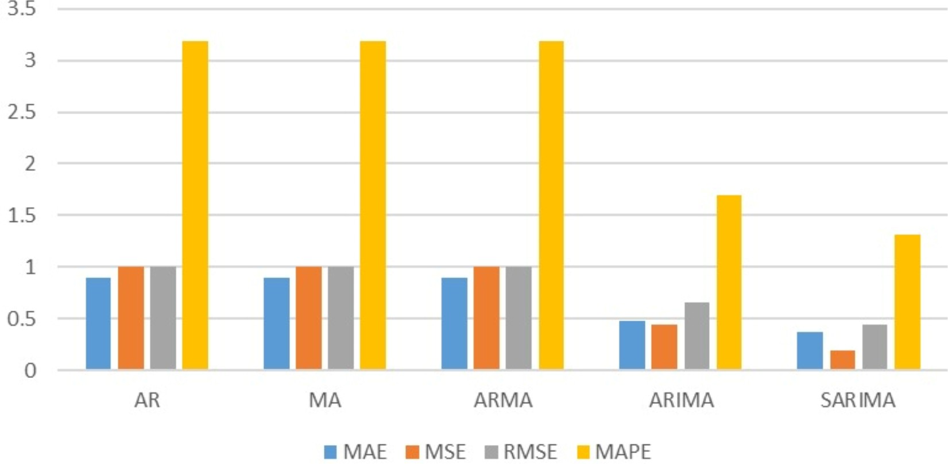

Fig. 1. Comparison Graph of Machine Learning Models

1. Experimental Results
2. *Recommendations and Predictions by the ML Model*

The time series model in this project forecasts future environmental conditions, such as temperature, dew point, and humidity, which are critical factors affecting solar panel performance. By analysing historical data, the model predicts these conditions for the upcoming hours or days, provid- ing insights into potential environmental changes that may impact solar panel efficiency. For instance, if the forecast indicates high humidity levels or a sharp rise in dew point, the system can predict an increased likelihood of dew or

moisture accumulation on the panel surfaces. Such predictions allow users to anticipate these conditions and take preventive measures, like scheduling panel cleaning during optimal times or deploying automated cleaning mechanisms when needed. The machine learning (ML) classification model uses these forecasted features to determine whether the solar panels need cleaning or maintenance. Based on patterns learned from past data, the model identifies conditions that typically lead to performance degradation, such as consistent high humidity or high temperature accompanied by a high dew point. When such conditions are predicted, the ML model outputs recommendations like “clean panels within the next 12 hours” or “schedule maintenance within the week.” These predictions are crucial for optimizing energy output, as they help minimize the impact of environmental factors on panel efficiency. The combination of time series forecasting and ML classification ensures that cleaning and maintenance actions are both timely and data-driven, enhancing overall system reliability and performance.

1. *Hardware Module Circuit Diagram*

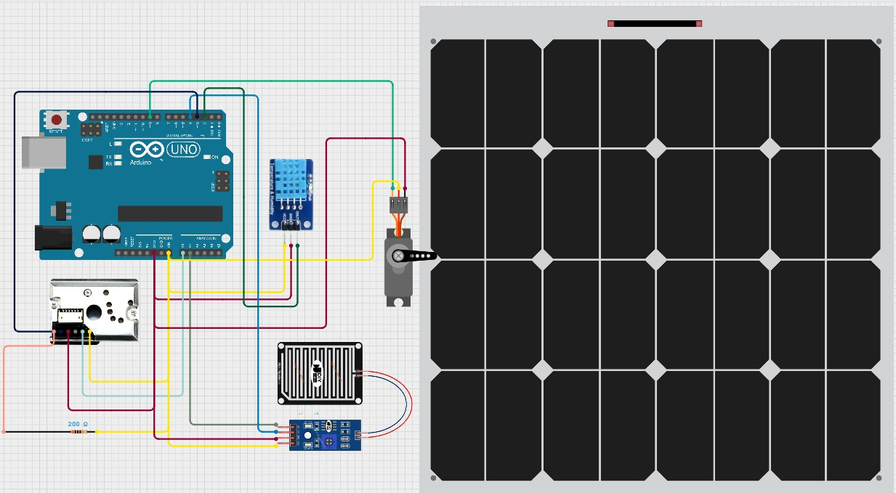

Fig. 2. Circuit Diagram

1. Modular Testing

Table I table outlines four hardware test cases. HW-TC1 tests sensor triggering by simulating increased dust levels. The system is expected to activate cleaning when the dust level exceeds 300 µg/m². HW-TC2 involves manually triggering the cleaning mechanism, where the brush is expected to complete a full sweep, cleaning 90 percent of the dust. HW-TC3 assesses power consumption efficiency by measuring power during active cleaning versus idle states. The expected outcome is an idle power consumption below 0.2W and an active cleaning power below 2.5W. Lastly, HW-TC4 tests the system’s weather adaptability by operating it under various weather conditions, ensuring it functions normally in different climates.

Table II outlines several software test cases aimed at validat- ing different aspects of a system related to sensor functionality and data processing. Test case SW-TC1 focuses on the accu- racy of machine learning (ML) predictions, ensuring that the system can predict cleaning requirements with an accuracy of at least 85 percent. Test case SW-TC2 examines the system’s

response to sensor failures by simulating a malfunction, where the expected outcome is for the system to alert the user and rely on historical data to maintain functionality. Test case SW- TC3 verifies the accuracy of the data displayed on the system’s dashboard by comparing it with raw data to ensure consistency. Finally, test case SW-TC4 assesses the speed of real-time data processing, where the system is expected to update data within 2 seconds.

TABLE I

Hardware Test Case

|  |  |  |  |
| --- | --- | --- | --- |
| **Hardware**  **Test Case ID** | **Objective** | **Procedure** | **Expected Out-**  **come** |
| HW-TC1 | Sensor Trig-  gering | Simulate an  increase in dust levels | Cleaning  activates when dust level ¿ 300 µg/m² |
| HW-TC2 | Cleaning  Mechanism Operation | Manually trigger  the cleaning mechanism | Brush  completes  a full sweep, cleaning 90% of dust |
| HW-TC3 | Power Con-  sumption Ef- ficiency | Measure power  during active cleaning vs. idle state | Idle power ¡  0.2W; active cleaning power  ¡ 2.5W |
| HW-TC4 | Weather  Adaptability | Test system in dif-  ferent weather con- ditions | System  functions under various weather conditions |

TABLE II

Software Module Testing

|  |  |  |  |
| --- | --- | --- | --- |
| **Software**  **Test Case ID** | **Objective** | **Procedure** | **Expected Out-**  **come** |
| SW-TC1 | ML  Prediction Accuracy | Compare  predictions with actual cleaning requirements | Prediction ac-  curacy *≥* 85% |
| SW-TC2 | System  Response  to Sensor Failures | Simulate a sensor  malfunction | System alerts  the user and uses historical data |
| SW-TC3 | Dashboard  Data Accuracy | Validate dashboard  analytics against raw data | Data on dash-  board matches with actual val- ues |
| SW-TC4 | Real-  Time Data Processing | Check how quickly  the system updates data | Data updates  within 2  seconds |

1. COMPARATIVE ANALYSIS
2. *Manual Cleaning Costs*

Automated solar cleaning systems like SolarCare, developed by companies like Tata Power Solar [12], offer substantial advantages over manual cleaning. Manual cleaning incurs labor costs of INR36,000 to INR96,000 annually, as teams of 3-4 workers must perform time-intensive cleaning sessions that

TABLE III

Integrated Testing

|  |  |  |  |
| --- | --- | --- | --- |
| **ID** | **Objective** | **Procedure** | **Expected Out-**  **come** |
| IT-TC1 | Validate sen-  sor data flow | Simulate increased  dust levels | System reads  dust levels and logs data on the dashboard  *≥* 85% |
| IT-TC2 | Test  automated cleaning activation | Exceed dust thresh-  old to trigger clean- ing | Cleaning  mechanism activates within 5  seconds |
| ITW-TC3 | Performance  during weather changes | Simulate various  weather conditions (rain, humidity) | System adjusts  cleaning schedule based on weather data |
| IT-TC4 | Handle sen-  sor malfunc- tion | Simulate sensor  disconnection | System alerts  user and  switches to predictive mode using ML data |
| IT-TC5 | Measure  power consumption | Record power us-  age during cleaning and idle states | Consumption  below 3  watts during cleaning, ¡0.5 watts when idle |

can cost INR600 to INR2,000 per session [13]. Additionally, manual methods require up to 1.92 million liters of water each year for a 1 MW solar farm with approximately 4,000 panels, costing an extra INR19,200 [13]. Residual water can also leave mineral stains, leading to further inefficiency. By contrast, SolarCare uses a dry microfiber brush system that eliminates the need for both water and labor, generating savings in both areas [13]. Dust accumulation on solar panels can reduce energy efficiency by 20-30 percent, translating into annual revenue losses of INR273,750 to INR547,500 for a 1 MW installation [14]. SolarCare mitigates this loss by keeping panels consistently clean, converting these efficiency losses into increased earnings. Although the system requires an initial investment of INR1.5 to INR2.5 million, this cost is typically recovered within 1-2 years due to savings on labor, water, and energy [16]. Maintenance for SolarCare does carry additional costs of INR50,000 to INR100,000 per year, which is higher than the INR10,000 for manual cleaning [14]. Nonetheless, SolarCare also significantly reduces safety risks, helping avoid potential liability costs of INR100,000 to INR500,000 associ- ated with manual cleaning [15]. Supported by reports from the Ministry of New and Renewable Energy (MNRE) [8], IREDA [11], and Tata Power Solar [12], SolarCare is positioned as a cost-effective, sustainable solution for solar panel maintenance in India.

1. *SolarCare Costs*

The SolarCare automated cleaning system offers a highly ef- ficient, resource-saving alternative to traditional manual meth-

ods of solar panel maintenance. By utilizing a dry cleaning mechanism with microfiber brushes, the system completely eliminates the need for labor and water, resulting in annual sav- ings of INR36,000 to INR96,000 on labor and INR19,200 on water usage for a typical 1 MW solar farm [15,16]. In addition, SolarCare maximizes energy efficiency by ensuring panels are cleaned regularly and effectively, preventing dust accumulation that can reduce energy output by 20-30 percent. This translates to additional earnings of INR273,750 to INR547,500 annually from increased energy production. Although the system incurs higher maintenance costs (INR50,000 to INR100,000) and depreciation (INR150,000 to INR250,000), these expenses are offset by the substantial operational savings and improved energy generation. The system also enhances safety by remov- ing the need for manual labor, reducing risks and potential liabilities. With an initial investment of INR1,500,000 to INR2,500,000, SolarCare’s cost is typically recouped within 1-2 years, making it a sustainable and profitable long-term solution for large-scale solar installations. [16]

TABLE IV

Comparative Cost Analysis

|  |  |  |  |  |  |  |
| --- | --- | --- | --- | --- | --- | --- |
| **Parameter** | **Manual**  **Cleaning Cost (INR)** | | **SolarCare**  **Cost (INR)** | **System** | **Annual Sav-**  **ings/Earnings with Solarcare** | |
| Labor Costs | 36,000  96,000 | to | 0 | | 36,000 to  96,000 *≥* 85% | |
| Energy  Efficiency (Losses vs. Earnings) | Loss  273,750  547,500 | of  to | Earnings of  273,750 to 547,500 | | 273,750  547,500 | to |
| Maintenance  Costs | 10,000  30,000 | to | 50,000 to 100,000 | | Additional cost  of 20,000 to  70,000 | |
| Depreciation  Costs | N/A | | 150,000 to 250,000 | | Annual depre-  ciation expense | |
| Human Life  and Safety Risks | 100,000  to 500,000  (risk costs) | | Minimal or no risks | | 100,000  500,000  (potential savings) | to |
| Initial  Investment | N/A | | 1,500,000  2,500,000 | to | Cost recouped  within 1-2  years | |
| Total  Annual Sav-  ings/Earnings | Loss  328,950  662,700 | of  to | Earnings  478,950  1,142,700 | of  to | 478,950  1,142,700 | to |

**(INR)**

1. Conclusion

This paper conducted research to demonstrate the effective- ness of an integrated system for real-time maintenance of the solar panel by connecting the cleaning mechanism and a model that involves machine learning. It possesses many advantages compared to traditional manual cleaning techniques, such as optimal maintenance scheduling resulting from sensor moni- toring of environmental conditions and consequent prediction of the necessity for cleaning, minimization of labor cost, saving of water resources. That leads to increasing efficiency in the generation of energy through the solar panel. The work

showcases that the system is cost-effective and will operate efficiently, which makes it a promising solution for solar farm owners and operators. In addition, the research mentions possible future improvements, such as advanced sensors and AI-based tracking, to further enhance the system’s efficiency and capabilities.

1. Future Work

Future development work in the SolarCare system will focus on optimizing capabilities, scalability, and adaptability to improve solar panel maintenance. Key improvements include: Advanced sensors that could predict dust accumulation and defects in panels more precisely by coupling air quality sensors with wind and thermal imaging sensors. Predictions enable timely cleaning and make resources usage optimal as during periods of rainfall, cleaning is not required. The new version will be fed with historical data to predict seasonal behavior and humidity for data-driven cleaning schedules. Adaptive algorithms improve predictive capabilities over time. Scala- bility will be ensured as it can be done through distributed sensor networks, via cloud integration- which efficiently will manage larger solar farms through real-time monitoring and centralized control features. Future technologies could be a tracking system in one direction with ball-and-socket joints, which enable panels to move according to the solar path. Algorithms based on AI will learn about the movement pat- terns according to real-time data and energy needs. Advanced predictive maintenance using machine learning identifies real- time problems, minimizes downtime, and maximizes effi- ciency. All these innovations are meant to give the highest production of energy by SolarCare while providing mass-scale, cost-free maintenance and conserving resource usage.

References

1. M. S. Nadeem, A. Ikram, and M. Z. Hameed, “Machine Learning in Renewable Energy Application: Intelligence System for Solar Panel Cleaning,” *ResearchGate*, May 2023.
2. A. K. Singh, N. Agrawal, and D. Kumar, “A Review on Solar Panel Cleaning Systems and Techniques,” in Proc. of International Conference on Solar Energy Research, 2023, pp. 22–30.
3. M. Anderson, K. Parker, and L. Williams, “High-Performance Comput- ing for Solar Panel Optimization,” in *Proc. of IEEE High-Performance Extreme Computing Conf. (HPEC)*, Sep. 2023, pp. 102–108.
4. S. A. Malik, R. Akhtar, and F. Rehman, “Smart Solar Panel Cleaning Systems for Enhanced Efficiency: A Comprehensive Review,” in *E3S Web of Conferences*, vol. 324, pp. 21–28, 2022.
5. T. Bhuyan, “Machine Learning-Based Approaches for Optimized Solar Panel Cleaning,” *Journal of Energy and Resources Research*, vol. 105, no. 6, pp. 650–662, 2023.
6. M. Hamid, P. Lakshmi, and I. Habib, “Advanced Solar Panel Cleaning Techniques Using AI: A Comparative Study,” *WSEAS Transactions on Environment and Development*, vol. 19, pp. 115–128, 2023.
7. D. Goyal, “AI in the Solar Panel Cleaning Industry: Challenges and Opportunities,” *AI in Industry Journal*, vol. 2, no. 5, pp. 10–18, 2023.
8. Ministry of New and Renewable Energy (MNRE), “Annual Report on Renewable Energy Developments,” 2022.
9. National Institute of Solar Energy (NISE), “Solar Panel Efficiency Improvements and Maintenance Guidelines,” 2022.
10. Solar Energy Corporation of India (SECI), “Solar Panel Projects and Financial Reports,” 2022.
11. Indian Renewable Energy Development Agency (IREDA), “Report on Solar Energy Financing and Policies,” 2022.
12. Tata Power Solar, “Labor Cost Justification and Reports,” 2022.
13. IEOM Society, “Water Conservation Data,” 2022.
14. IEOM Society, “Dust Buildup Efficiency Losses,” 2022.
15. Tata Power Solar, “Safety Risks and Manual Cleaning Data,” 2022.
16. IEOM Society, “Long-Term Savings and ROI Analysis,” 2022.